Tabula Insurance Agency

Enter and update company data

* PROJECT STEPS

1. As the office administrator, you use Excel to maintain personnel data and summarize cash flow. You are finalizing the *Personnel* and *Cash Flow* worksheets for the current week.   
     
   Begin on the *Personnel* worksheet by cutting the contents of the range B1:B2 and pasting them into the range A1:A2.
2. Adjust the width of column A using **AutoFit**.
3. Change the width of column B to **16.00**.
4. Enter the values shown in Table 1 into the corresponding cells in the range B14:C16.

* Table 1: Data for the Range B14-C16

|  |  |  |
| --- | --- | --- |
|  | B | C |
| 14 | **846.15** | **23.22** |
| 15 | **846.15** | **5.19** |
| 16 | **923.08** | **0.00** |

1. Enter **albert.luna@cengage.com** in cell D5. Select the range D5:D16, and then use the Flash Fill button (in the Editing group on the Home tab) to automatically enter codes into the remaining cells in the ra nge. (*Hint:* You must use the Flash Fill button to receive credit for this step.)
2. Change the width of column D to **36.00**.
3. Enter the word **Total** in cell A17**.**
4. In cell B17, create a formula using the **SUM** function to determine the total salary paid by Tabula Insurance Agency by totaling the values in the range **B5:B16**. Copy the formula you created in cell B17 to cell C17.
5. Enter **Number of Employees** in cell A19.
6. In cell B19, create a formula using the **COUNT** function to determine the number of people employed by Tabula Insurance Agency by counting the values in the range **B5:B16**.
7. Enter the text **Average Commission** in A21.
8. Switch to the *Cash Flow* worksheet. Change the orientation of the *Cash Flow* worksheet to **Landscape**.
9. In cell A2, change the cell content to **Cash Flow: April 4-10, 2021** (instead of just reading "April 4-10, 2021").
10. Select the range A4:E4 and the nonadjacent cell G8, and then increase the font size of the cells to **12 point**.
11. To better display the content, manually change the height of row 3 to **8.00**. (*Hint*: Do not use AutoFit.)
12. In cell B7, enter a formula without using a function to determine the profit generated from auto insurance policies by subtracting auto expenses (cell **B6**) from auto sales (cell **B5**) for the week of April 4-10, 2021. Copy the formula you created in cell B7 to the range C7:D7.
13. After determining the total profits generated by each store, you are now interested in calculating the total sales, expenses, and profits across all types of insurance sold. Select the range E5:E7, and then apply **AutoSum** to calculate the totals for these categories across all three types of insurance.
14. Since you just edited the worksheet, the content in cell A9 is no longer accurate. Click on cell A9 and clear its contents.
15. Apply the **Wrap Text** formatting to cell G8.
16. Adjust the Zoom level of the *Cash Flow* worksheet to **130%**.
17. After reviewing the *Personnel* and *Cash Flow* worksheets, you typically generate some additional data for accounting. To create a placeholder worksheet for this data, insert a new worksheet in the workbook, rename the worksheet **Accounting**,and if necessary, move the new worksheet after the *Cash Flow* worksheet.

Your workbook should look like the Final Figures on the following pages.

* Final Figure 1: Personnel Worksheet

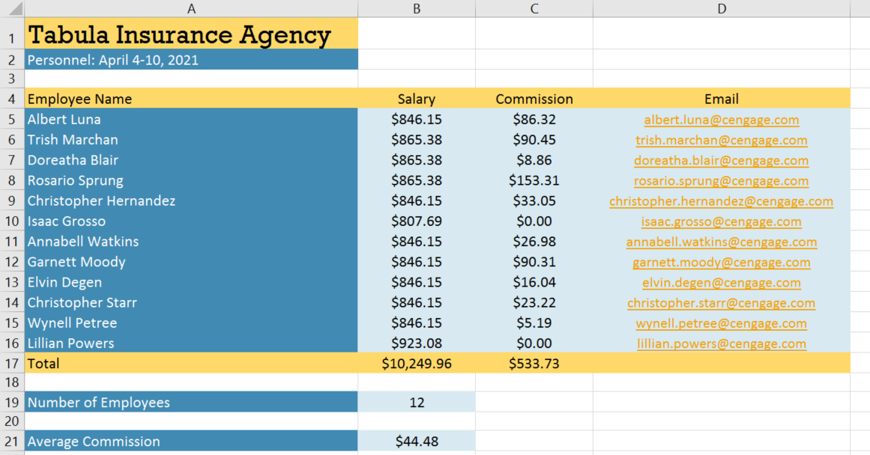

* Final Figure 2: Cash Flow Worksheet

